# 1-1 Resources

## Waterfall:

One challenge with the **waterfall model** is that it considers “planning” to be a phase that you do up front and then do not revisit as you progress.

Each step is planned out before the cycle begins. It is linear and sequential, so the previous phase must be completed before moving onto the next.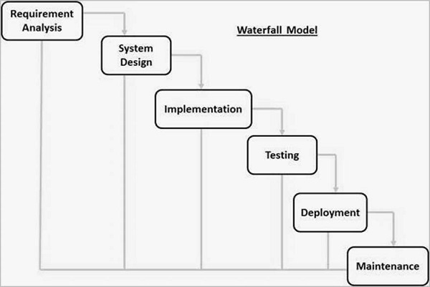

In 1970, Dr. Winston Royce published a famous paper on “Managing the Development of Large Software Systems.” This paper is now associated with the waterfall method and outlined an approach for breaking up a large complex software project into sequential phases to manage the effort.

The original model Dr. Royce proposed in his paper: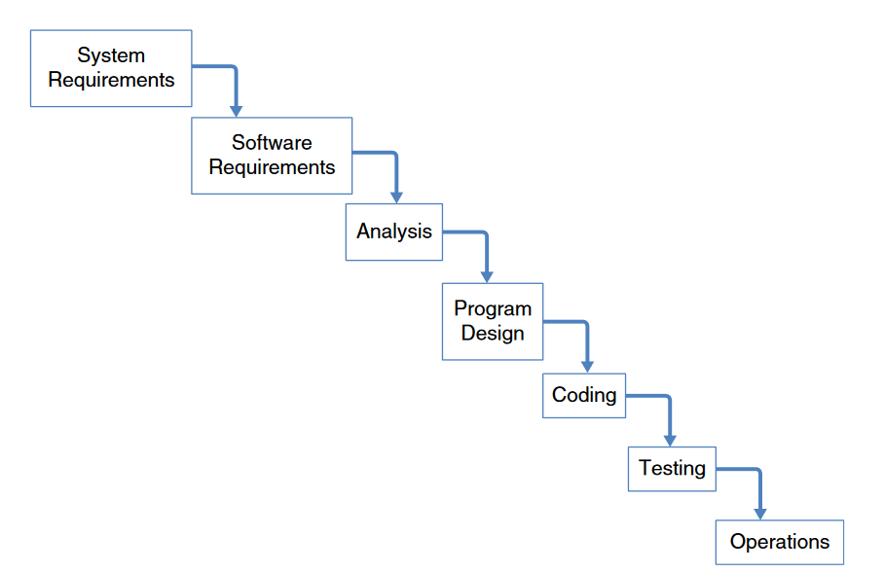

However, Dr. Royce pointed out the weaknesses in this approach: “The testing phase.. is the first event for which timing, storage, input/output transfers etc., are experienced as distinguished from analyzed. “The entire process was sequential, and an error or omission made in one of the very early phases of the project may not have been discovered until the very end of the project” “which might require huge amounts of rework”

His son, Walker Royce, contributed to the development of iterative and incremental development methods and said the following about his father’s thinking:

* “...always a proponent of iterative, incremental, evolutionary development”
* “His book described waterfall as the simplest solution, but that it would not work for all but the most straightforward projects”

## Agile:

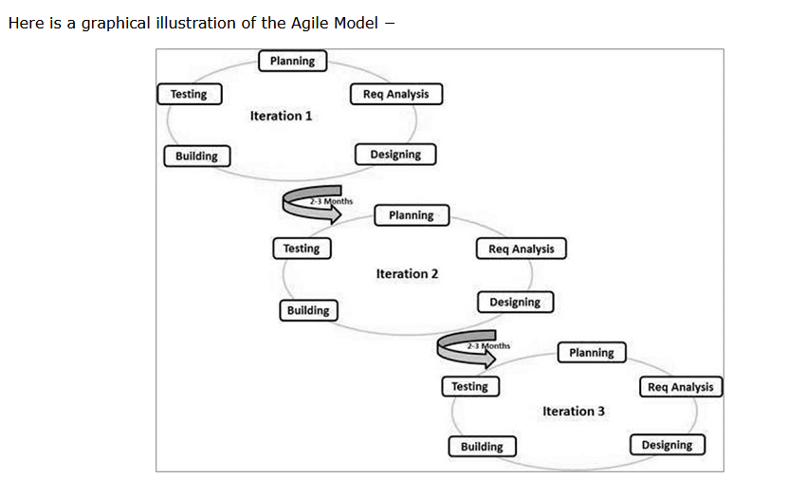

Agile Methods break the product into small incremental builds. These builds are provided in iterations. Each iteration typically lasts from about one to three weeks. Every iteration involves cross functional teams working simultaneously on various areas like −

* Planning
* Requirements Analysis
* Design
* Coding
* Unit Testing and
* Acceptance Testing

Agile enables flexibility by setting up shorter bursts of work and creating room for iteration and adaptation. Adaptive to uncertain and changing user requirements. The process is adaptive rather than prescriptive. Based on continuous improvement.

From 2008 to 2013, agile use tripled. According to a 2013 survey, 88% of respondents say their organizations use agile, up from 80% in 2011.

Broken up into short iterations (cycles) called *sprints* that are two to four weeks in length. At the end of every *sprint*, there must be a “shippable product”. Therefore, quality testing must be more integrated with development.

“Agile Manifesto” (2001)

*Manifesto for Agile Software Devlopment,* or the Agile Manifesto, published in 2001, is what many people point to as the “true beginning” of the agile movement.

### Benefits to the agile approach:

* Increased focus on business outcomes
  + Each part of the cycle varies in length. Using agile allows businesses to adapt their approach and get the project done faster.
* Reduced time to market
  + Reducing startup time required for projects by simplifying some of the requirements definition practices.
  + Improving the efficiency of the overall project and delivering functionality incrementally as much as possible.
* Higher productivity and lower costs
  + Eliminates unnecessary overhead and bottlenecking by doing work concurrently rather than sequentially.
* Higher quality
  + By including all parts of a team in the process, they will feel responsible for the quality of the products they produce.
* Organizational effectiveness
  + “a very important benefit of agile is a more effective organization with higher morale”

### “Agile vs Waterfall”

Agile and waterfall should not be thought of as mutually exclusive. Instead, they should be thought of as complementary.

By adapting your approach to the project instead of using a plan-driven approach for everything “will generally result in a number of benefits”

# 1-1 Discussion: Introductions & Models

Throughout this course, you will work with your peers to create a community where you can ask each other questions, share ideas, and build your skills together. In your initial post for this discussion, introduce yourself to your peers and discuss your career aspirations. Then address each of the following prompts:

* Based on your experience in the SNHU Computer Science program, work experience, or ideas from the module readings or outside sources, what are the existing issues with the waterfall development model?
* How do you see the Agile methodology resolving these issues?
* What aspects of the Agile methodology will impact those issues the most?
* What factors are driving the rise of the Agile methodology?

In your responses to your classmates, address the following question:

* How can Agile methodology help development teams complete projects on time and within their budget?

**Post:**

Hi everyone!   
I’m Nevaeh and I am from the northeast USA. My career aspiration would probably be a data analyst role or something similar. I have prior knowledge of SDLC so I hope this course will be a breeze!  
Based on reading Chapter 1 and 2, and my prior knowledge of development models, the waterfall model has a few issues. The number one issue is that by using the waterfall model, as it is sequential, multiple phases cannot be completed at once. This makes it less efficient. It also treats planning as a one-time-only phase. Because of this, an error made in one of the very early phases may not be discovered until the very end of the project.

I see agile resolving these issues because it allows multiple phases to be completed at once. As each part of the phase is now adaptable, it may take less time to receive a finished product. But as quality is closely integrated with production, there is always an option to take longer.

The rise of Agile methodology is driven by several factors:

* Faster Time-to-Market
  + Agile’s focus on rapid iteration and quality deliveries enables teams to get products to market faster
* Improved Collaboration
  + Agile’s focus on rapid iteration and quality deliveries enables teams to get products to market faster
* Scalability
  + Agile can be applied to projects of all sizes, from small to large, and can be scaled up or down as needed.
* Improved Quality
  + Agile's focus on continuous testing, feedback, and improvement leads to higher-quality products and services.

There are more factors than what I have listed here, but I believe these to be the main reasons why.

# 1-3 Quiz: SDLC and Methodologies

**What is SDLC?**

The Software Development Life Cycle is a framework that defines tasks performed at each step in the software development process.

**What are the different stages in the waterfall model approach to the SDLC?**

Requirements analysis, system design, implementation, testing, deployment, and maintenance

**What is the most important lean principle to understand and maximize?**

Flow

**What are some of the major benefits of an agile approach to the SDLC?**

It gives flexibility to developers and allows for changing requirements during development.

It delivers early, partial working solutions so progress can easily be measured.

**Which is not a design model of the software development life cycle?**

Sunshine model

**What is one of the major disadvantages of the waterfall model approach to the SDLC?**

Working software is not produced until late in the life cycle, which creates high amounts of risk and uncertainty.

**What is a Kanban process?**

A pull process, reactive to the customer